# Updating feature information using GeoServer rest API.

In this approach, I am attempting to update the feature information of a published layer in GeoServer using the GeoServer REST API. I am utilizing the WFS service of the layer for updating the feature information. However, I have encountered the following issues in this process.

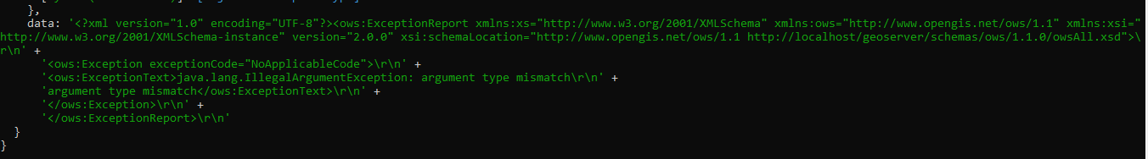

# Updating the Geometry with the help of Open layers and WFS service.

In this approach I am attempting to update the feature information of a published layer with the open layers and WFS service. However, I have encountered the following issues in this process.

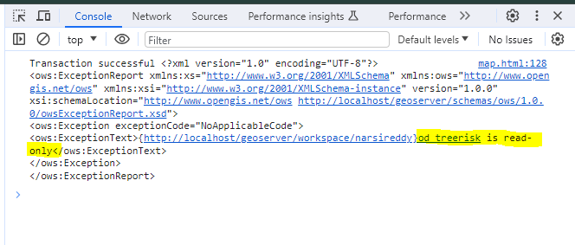

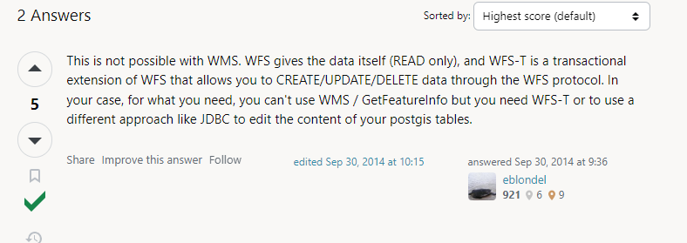

# Updating the feature information with WFS-T

In this approach I am attempting to update the feature information of a published layer with the open layers and WFS- Transaction service. However, I have encountered the following issues in this process.

We can see the success message indicating that the feature has been updated. However, the geometry is not being updated in the PostgreSQL table.

